# Modifications to sound of UWPXAudio2Theremin App

John Bradon, 28th June 2018

## Background – Reason for modifications

Using the app, I noticed two things which I felt could be improved.

1. 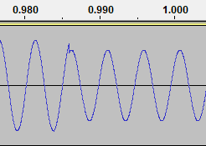When a user starts a sound, ends the sound or changes the volume, a click can be heard.

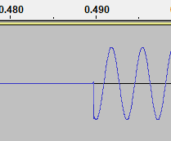

Volume change

start

1. 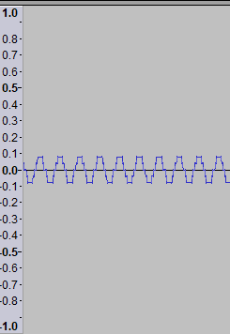When the volume is low, the timbre of the sound changes. It sounds more like a square wave than a pure sine tone.

As picture of the recorded output shows, converting the sine function to an 8-bit sample significantly changes the shape when the volume is low.

## Proposed Solutions

1. Only change the volume at a zero crossing point. This is done by adding a new variable called inUseVolume which is only changed (to currentVolume*masterVolume;) at a crossing point. Crossing points are easy to identify using the existing variable, pos. When pos is 1, the output sin(2 * PI * pos) is zero, so the volume can be changed without making a click.
2. Use 16 Bits Per Sample rather than 8. Three of the waveformatx parameters have to be changed: wBitsPerSample , nAvgBytesPerSec and nBlockAlign. However, Xaudio 2 still needs to refer to the data in the buffer as BYTES (in xaudio_buffer.pAudioData). Note: now there are two bytes per sample. An efficient solution to this is to define a new structure in AudioComponent.h which uses union to refer to the same data as a 16 bit integer and as 2 BYTES. (see Union in second section in [http://www.cplusplus.com/doc/tutorial/other](http://www.cplusplus.com/doc/tutorial/other%20) ). The new structure is called a byteint type as it can be used as either int16 or BYTE.

## Results

Start of a sound

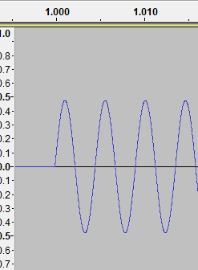

Low volume fade out of a sound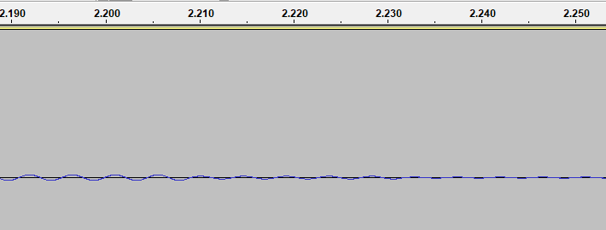

## Summary of Code Changes

Two files are changed: AudioComponent.h and AudioComponent.cpp.

All changes are temporarily commented starting //jb; with an explanation of the change.